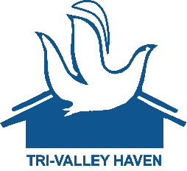
Tri Valley Haven’s Wish List
Underlined items have direct product links to Amazon.
Please send Food Pantry donations to 418 Junction Avenue, Livermore, CA
For all other donations please send to 3663 Pacific Avenue, Livermore, CA
- Women’s Underwear (Multiple Sizes)
- Amazon Gift Cards
- Baby Formula
- Baby Wipes
- Toilet Paper
- Paper Towels
- Pots and Pans
- Cooking Utensils
- Pillows
- Mattress Covers – Twin Size Only
- Dinnerware Sets
- Bath Towel Sets
- Gas Cards - Visas
- Kitchen Cleaning Supplies
- Laundry Detergent
- Mops
- Silverware
- Comforter Set – Twin Size Only
- Bath mats
- Face Masks

Food Pantry Department
- Flour
- Coffee (instant or ground)
- Oil
- Juice
- Toilet Paper
- Sugar
- Seasonings
- Tortillas
- Paper Towels
- Baby Wipes
- Diapers (Any size)
- Empty Egg Cartons

