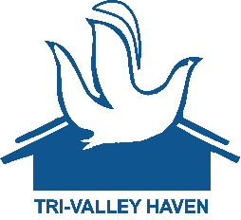
Tri Valley Haven’s Wish List
Please send Food Pantry donations to 150 North L Street, Livermore, CA
For all other donations please send to 3663 Pacific Avenue, Livermore, CA
- Women’s Underwear (Multiple Sizes)
- Amazon Gift Cards
- Baby Formula
- Baby Wipes
- Toilet Paper
- Paper Towels
- Pots and Pans
- Cooking Utensils
- Pillows
- Mattress Covers – Twin Size Only
- Dinnerware Sets
- Bath Towel Sets
- Gas Cards - VISA
- Kitchen Cleaning Supplies
- Laundry Detergent
- Mops
- Silverware
- Sheet Sets
- Comforter Set – Twin Size Only
- Bath mats
- Face Masks

Food Pantry Department
- Flour
- Coffee (instant or ground)
- Oil
- Juice
- Toilet Paper
- Sugar
- Seasonings
- Tortillas
- Paper Towels
- Baby Wipes
- Diapers (Any size)
- Empty Egg Cartons

